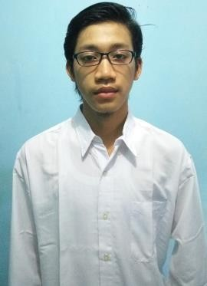

**CURRICULUM VITAE**

**Nugroho Agung Cahyono**

**Personal Data**

Date of birth : Sragen, August 17th 1996

Gender : Male Status : Single Religion : Moslem

Address : Sidoharjo, Sragen

Phone number : +628967329057

Email : [nugrohoac96@gmail.com](mailto:nugrohoac96@gmail.com)

**Formal**



|  |  |  |
| --- | --- | --- |
| Year | School/Institution name | Department |
| 2001-2007 | SDN Patihan III | - |
| 2007-2010 | SMPN 2 Sidoharjo | - |
| 2010-2013 | SMAN 1 Sragen | Science |
| 2013-present | Bogor Agricultural University | Computer Science |

**Non - Formal**



|  |  |  |
| --- | --- | --- |
| Year | Institution name | Program |
| 2012-2013 | Newtron | Science |

**Organizational Experience**



|  |  |
| --- | --- |
| Year | Position |
| 2010-2013 | Member of Rohis SMA N 1 Sragen |
| 2010-2013 | Member OSIS SMA N 1 Sragen |
| 2013-2014 | Member of Cybertron (Group Asrama TPB IPB) |
| 2014-2015 | Organizer of Sragen University Expo 4th |

1. Mathematics PASIAD (2007)

2. OSN Physics (2008)

3. Mathematics PASIAD (2010)

**Academic Record**



1. Computer Application (HTML)

2. Algorithm and Programming (C language)

3. Digital Circuit

4. Programming Language (C++, Scheme, Prolog,Java)

5. Data Structure (C++)

6. Computer Organization (Assembly)

7. Database (MySQL)

8. Automata Theory and Languages

9. Artificial Intelligence

10. Graphical Computer (GLFW)

11. Operation System

12. Software Engineering (PHP, JSON)



1. Node.Js
2. MongoDB
3. MySQL
4. Codeblocks
5. Terminal
6. GNU Prolog
7. DrRacket
8. R Studio
9. Weka
10. Matlab
11. Scilab

**Experience**

Quick count of elections in 2016 with Indo Barometer organization

integrated televison station (SCTV, Metro TV)

Quick count of elections DKI Jakarta 1 in 2017 with Indo Barometer

Quick count of elections DKI Jakarta 2 in 2017 with Indo Barometer

**Passion**

*Front-End Engineer*